20/03/25
THM 415: Finance
Midterm Exam Answer Sheet
- Why shall investors expect a minimum rate of return even on risk-free investments? (2 Points)
Investors still expect a rate of return (even if it is minimum) when undertaking risk-free investments because they require a rate of return for their delayed consumptions.
- Arroyo Hotel had recorded the following income statement accounts sorted in alphabetical order:
Cost of Goods Sold | $1,856,879
Interest Expenses | $314,314
Operating Expenses | $723,569
Sales | $4,253,689
In addition, since Arroyo Hotel owns 47 % shares of Keny Company, it is entitled to $ 1,314,750 of dividends income from that very company. Moreover, Arroyo hotel’s board of directors decided to distribute $ 385,000 as dividends to their shareholders.
The following table reveals Income Tax Rates for Corporate Income for 2024 fiscal year:
Taxable Income | Marginal Tax Rate
$ 0 – $ 100,000 | 15%
$ 100,001 - $200,000 | 17%
$ 200,001 - $ 400,000 | 19%
$ 400,001 - $ 575,000 | 21%
$ 575,001 - $ 900,000 | 23%
$ 900,001 - $ 1,500,000 | 25%
Over $ 1,500,000 | 33%
Lastly, the following table shows dividend income exclusion to avoid double taxation at corporate level.
Ownership Interest | Dividend Exclusion
Less than 20 % | 18%
20 % to 35 % | 28%
35 % to 55 % | 38%
55 % to 75 % | 58%
75 % to 85 % | 78%
More than 85 % | 100%
a) Construct Arroyo Hotel Income Statement for the year ended December 31st, 2024. (2 Points)
Moreover, the following is Arroyo Hotel’s comparative balance sheet as of December 31st, 2023 and December 31st, 2024:
- Construct Arroyo Hotel Statement of Cash Flow for the year ended December 31st, 2024. (3 Points)
- Calculate the Quality of Earnings. Interpret your result. (1 Point)
- Quality of Earnings = (Cash Flow from Operations) / (Net Income) = 869,779 / 804,983 = 108.05 %.
Thus, in 2024, Arroyo Hotel’s cash flow from operations was 108.05 % of the firm’s reported net income.
- Calculate the Capital Acquisition Ratio. Interpret your result. (1 Point)
- Capital Acquisition Ratio = (Cash Flow from Operations) / (Cash Paid for Capital Expenditures) = 869,779 / 153,000 = 568.48 %.
Thus, in 2024, Arroyo Hotel generated, from its operations, cash flow that is able to finance 5.68 times of its new expenditures for plant and equipment.
- Based on the income statement prepared in part a), comparative balance sheet and cash flow statement prepared in part b), analyze the financial situation of Arroyo Hotel for the fiscal year 2024. (3 Points)
Income Statement:
- In 2024, Arroyo hotel is a profitable company as its revenues (i.e. sales) are greater than its costs.
- In 2024, Arroyo Hotel’s mark-up on its cost of goods sold is 56.35 %.
- In 2024, for each dollar of revenue, Arroyo Hotel is left with 39 cents after deducting all its operating expenses.
- In 2024, each one dollar of sales is associated with 18.92 cents of net income.
Balance Sheet:
- Arroyo hotel is a highly liquid company as its net working capital is $ 866,560. This means that current assets can shrink by as much as $ 866,560 and the company would still be able to pay its current liabilities.
- In Arroyo Hotel, the purchases of assets are financed 41.33 % through debt and 58.67 % through equity.
- For each one dollar of net income, 52.17 cents are retained in the business.
Statement of Cash Flow:
Cash flow from operating activities:
- Arroyo Hotel has positive cash flow from operating activities.
- The primary contributors to the operating cash flows were net income and depreciation expense.
- Inventories and other current assets are the contributors of cash usage.
Cash flow from investing activities:
- Arroyo Hotel invested $ 153,000 in purchasing fixed assets. This represents 17.59 % of the total cash flow generated from operations.
Cash flow from financing activities:
- Arroyo Hotel has negative cash flow from financing activities.
- Cash usage resulted from payment of already declared dividends, purchase of marketable securities, payment of short-term notes as well as payment of long-term debts.
- The contributors to cash were the issuance common stock (par), and common stock (paid-in-capital).
- Suppose you would like to double your investment. For this purpose, you deposited in a bank $ 23,149.38 to be compounded quarterly at an interest rate of 4.25 %. Calculate the period (in years) needed to reach your objective? (1 Point)
- Interest Rate = 4.25 % / 4 = 1.0625 %; Present Value = - $ 23,149.38; Payment = $0; Future Value = $ 42,298.76.
Answer: Nper (1.0625 %, 0, -23149.38, 42298.76) / 4 = 16.40 Years.
Therefore, it would take 16.40 years for an investment of $ 23,149.38 to double at an annual interest rate of 4.25 % compounded quarterly.
- After examining the various interest rates opportunities, you find that you can invest in a finance company at 9.53 % compounded monthly, from bank A at 9.50 % compounded weekly.
a) Which alternative is the most attractive? Why? (1 Point)
- Investing in Finance Company: Effective Annual Rate= Effect (9.53 %, 12) = 9.96 %.
- Investing in bank A: Effective Annual Rate = Effect (9.50 %, 52) = 9.96 %.
Since I am investing, I shall choose the offer that has the highest Effective Annual Rate. Therefore, I shall invest in Finance Company (9.9575 % for Finance Company vs. 9.9564 % for Bank A).
b) If you wanted to consider Bank B which offers continuous compounding. What is the minimum interest rate suggested by this very bank to start thinking about the offer? (1 Point)
Bank B shall give me a minimum rate of 9.49 % to start thinking about the offer.
- Joao wanted to buy a home that costs $ 500,000. He took a 10-year mortgage loan with semi-annual payments at an annual rate of 3.14 %.
a) How much will Joao pay each period? (1 Point)
Interest = 3.14 % / 2 = 1.57 %, Period = 10 * 2 = 20; Present Value = $ 500,000; Future Value = $ 0
Answer: Payment (1.57 %, 20, 500000, 0) = $ - 29,324.22.
b) Fill in the amortization schedule. (3 Points)
Period | Amount Owed on the Principal (Beg. Period) ($) | Annuity Payment ($) | Interest Portion of the Annuity ($) | Repayment of the Principal Portion of the Annuity ($) | Outstanding Loan Balance ($)
1 | $500,000.00 | $29,324.22 | $7,850.00 | $21,474.22 | $478,525.78
2 | $478,525.78 | $29,324.22 | $7,512.85 | $21,811.37 | $456,714.41
3 | $456,714.41 | $29,324.22 | $7,170.42 | $22,153.81 | $434,560.60
4 | $434,560.60 | $29,324.22 | $6,822.60 | $22,501.62 | $412,058.98
5 | $412,058.98 | $29,324.22 | $6,469.33 | $22,854.90 | $389,204.08
6 | $389,204.08 | $29,324.22 | $6,110.50 | $23,213.72 | $365,990.36
7 | $365,990.36 | $29,324.22 | $5,746.05 | $23,578.18 | $342,412.18
8 | $342,412.18 | $29,324.22 | $5,375.87 | $23,948.35 | $318,463.83
9 | $318,463.83 | $29,324.22 | $4,999.88 | $24,324.34 | $294,139.49
10 | $294,139.49 | $29,324.22 | $4,617.99 | $24,706.23 | $269,433.25
11 | $269,433.25 | $29,324.22 | $4,230.10 | $25,094.12 | $244,339.13
12 | $244,339.13 | $29,324.22 | $3,836.12 | $25,488.10 | $218,851.03
13 | $218,851.03 | $29,324.22 | $3,435.96 | $25,888.26 | $192,962.77
14 | $192,962.77 | $29,324.22 | $3,029.52 | $26,294.71 | $166,668.06
15 | $166,668.06 | $29,324.22 | $2,616.69 | $26,707.54 | $139,960.53
16 | $139,960.53 | $29,324.22 | $2,197.38 | $27,126.84 | $112,833.68
17 | $112,833.68 | $29,324.22 | $1,771.49 | $27,552.74 | $85,280.95
18 | $85,280.95 | $29,324.22 | $1,338.91 | $27,985.31 | $57,295.63
19 | $57,295.63 | $29,324.22 | $899.54 | $28,424.68 | $28,870.95
20 | $28,870.95 | $29,324.22 | $453.27 | $28,870.95 | $0.00
c) Suppose that exactly after 4 years, mortgage interest rates fell to 2.58 %. If Joao has the chance to refinance his loan at that very interest, how much would he pay (on a semi-annual basis) for the remaining 6 years of the loan? (1 Point)
Interest = 2.58 % / 2 = 1.29 %, Period = 6 * 2 = 12; Present Value = $ 318,463.83; Future Value = $ 0
Answer: Payment (1.29 %, 12, 318463.83, 0) = $ - 28,816.19
d) If such a refinance opportunity is associated with paying a prepayment penalty fee to the bank of $ 5,500, shall Joao refinance his loan? Why? Why not? (2 Points)
The answer to this question lies in coming up with cash flow increments by taking the difference of cash flows (for each of the remaining 6 years) between the first scenario (i.e. continuing paying $ 29,324.22) and second scenario (i.e. paying $ 5,500 as a penalty in year 0, and saving $ 508.04 for the remaining 12 six-month period). To sum up, the following table reveals the cash flow increments from opting for the second scenario:
As can be seen from the above table, paying $ 5,500 as a pre-payment penalty but start saving $ 508.04 for the remaining 12 six-month period (i.e. 29,324.22 – 28,816.19) would yield a positive return. Hence, Joao shall re-finance the mortgage loan since he will be better off when opting for the second scenario.
- Upon evaluation of the distribution of returns of Ernest company, the following possible rate of returns for the upcoming period as long as their probability of occurrence are estimated:
Probability of Occurrence | Rate of Return on Investment
8% | -5.14%
13% | -4.32%
14% | -2.25%
18% | 2.23%
19% | 5.58%
16% | 9.03%
12% | 10.53%
a) Calculate the Expected Rate of Return of Ernest Company stock. (1 Point)
- Expected Rate of Return = (8 % * - 5.14 %) + (13 % * - 4.32 %) + (14 % * - 2.25 %) + (18 % * 2.23 %) + (19 % * 5.28 %) + (16 % * 9.03 %) + (12 % * 10.53 %) = 2.88 %.
b) What is the risk of the investment in Ernest Company stock as measured using the standard deviation of possible future rates of return? (2 Points)
- Elan bought some stocks of Ricardo Company worth of 100,000 Euros 8 years ago. Following is the beginning value of Elan bought stocks 8 years ago as well as the values at the end of each year up until today (the end of year 8):
Year | Stock Value (Euros)
0 | 100,000.00
1 | 96,860.00
2 | 94,370.70
3 | 95,012.42
4 | 99,316.48
5 | 104,331.96
6 | 107,754.05
7 | 114,574.88
8 | 112,363.59
a) What will be the annual rate of return that Elan expects to earn next year, if he plans to continue holding Ricardo Company stocks? (1 Point)
- Annual rate of return that Elan expects to earn next year, if he plans to continue holding Ricardo Company stocks = (- 3.14 % - 2.57 % + 0.68 % + 4.53 % + 5.05 % + 3.28 % + 6.33 % - 1.93 %) / 8 = 1.53 %.
b) What annual rate of return that Elan expects over a three-year horizon from holding Ricardo Company stocks? (1 Point)
- Annual rate of return that Elan expects over a three-year horizon from holding Ricardo Company stocks = ((1 + 3.28 %) * (1 + 6.33 %) * (1 - 1.93 %)^^{(1/3)}) – 1) = 2.50 %.
- You own a portfolio consisting of the following stocks:

Stock | Portfolio Allocation | Beta | Exp. Rate of Return
1 | 17.00% | 0.80 | 11.03%
2 | 28.00% | 0.98 | 11.95%
3 | 15.00% | 1.03 | 12.25%
4 | 18.00% | 0.53 | 8.54%
5 | 22.00% | 1.24 | 13.44%

Assume the risk-free rate is 3.85 % and the expected return on the market portfolio is 12.03 %.
- Calculate the expected return of your portfolio. (0.50 Points)
- Expected return (Portfolio) = (17 % * 11.03 %) + (28 % * 11.95 %) + (15 % * 12.25 %) + (18 % * 8.54 %) + (22 % * 13.44 %) = 11.55 %.
- Calculate the portfolio beta. (0.50 Points)
- Beta (Portfolio) = (17 % * 0.80) + (28 % * 0.98) + (15 % * 1.03) + (18 % * 0.53) + (22 % * 1.24) = 0.93.
- Plot the security market line on a graph. (2 Points)
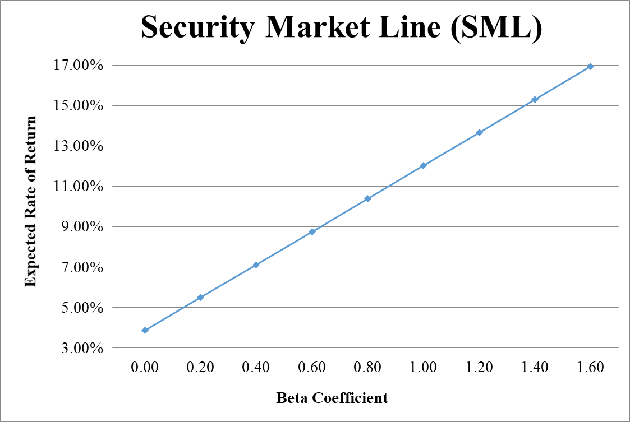
- From your plot in part c, which stocks appear to be your winners, and which ones appear to be losers? Explain the reason behind your conclusion. (2 Points)
- Logic → If Expected Return < SML Expected Return → Loser, otherwise Winner.
- Why should you consider your conclusion in part d) to be less than certain? (1 Point)
This conclusion is based on our having the right betas. Recall that calculation of Betas are subjective (i.e. depend on the market to be chosen, sample size, time interval chosen, definition of period…). If all of our betas understate their stock’s systematic risks, then we would be underestimating our portfolio risk.
GOOD LUCK!

